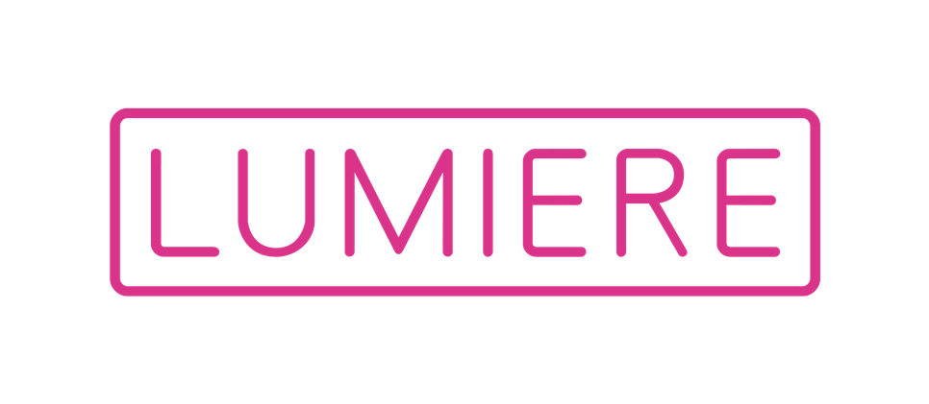
BRILLIANT 2023
Information Pack

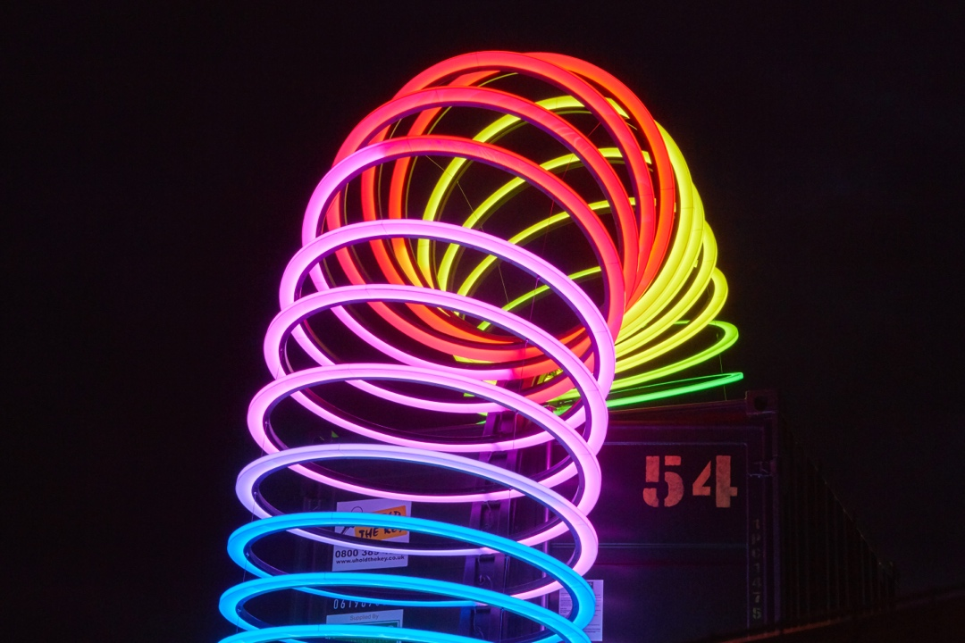
‘End Over End’, Lucy McDonnell, Lumiere Durham 2019. Produced by Artichoke.
Photo by Matthew Andrews

Closing date for applications
Sunday 19 February 2023, 11:59pm

BRILLIANT 2023 is sponsored by EMG Solicitors

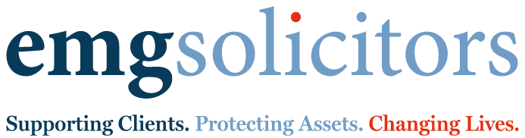
CONTENTS
p.3 – Introduction
p.3 – Your Idea
p.4 – Sustainability
p.4 – Artwork Location
p.5 – Eligibility
p.6 – Inclusion and Diversity
p.6 – What You Get
p.6 – How to Apply
p.8 – Selection Criteria
p.9 – Support
p.9 – Key Things to Remember

Thank you for your interest in applying for BRILLIANT 2023. Please read this information pack before you complete the application form.

The closing date for applications is Sunday 19 February 2023, 11:59pm.

This information pack is available in: Large print, Plain text and Audio recording.

You can download these formats from the Lumiere website: https://www.lumiere-festival.com/brilliant-2023/
Artichoke is committed to broadening the diversity of those working in the medium of light art and encourages applications from people who are currently under-represented in our BRILLIANT alumni, including people of colour and people who identify as d/Deaf, disabled or neurodivergent.
Getting help to apply: We are very happy to answer any questions. Please get in touch if you would like additional support with making your application.

Contact us at:
020 7650 7611 (Mon - Fri, 10:00 -18:00) / brilliant@artichoke.uk.com

INTRODUCTION

Lumiere 2023
Since 2009, Lumiere has attracted over one million visitors and is the landmark event in the cultural calendar of the North East. The UK’s light art biennial returns to Durham from 16-19 November 2023. Artichoke, the producer of Lumiere, invites national and internationally-renowned artists to transform Durham's iconic buildings and urban landscape with a thought-provoking programme of spectacular light artworks.

BRILLIANT: What is it?
BRILLIANT is your chance to be part of the bold and ambitious programme for 2023 and become a Lumiere artist.

The national commissioning scheme is aimed at encouraging anyone (aged 18 or older) with an interest in using light creatively, to suggest their brightest idea for an artwork to be produced and exhibited at Lumiere 2023.

The scheme aims to encourage creativity across the UK as well as highlighting brilliant ideas from people living in or originally from North East England.

Successful applicants will be supported by Artichoke with the production costs and technical expertise to create and install their artwork and will receive a fee.

You don’t need to be a practising artist or have any previous experience to apply to BRILLIANT. You just need a brilliant idea.

YOUR IDEA
There is no set theme for BRILLIANT. We want to see your best and most inspired idea for an artwork using light. The Lumiere programme is always diverse and ambitious, so be bold and think outside the box.

Ideas and inspiration:
- Something that is important to you
- Durham’s unique history, people, stories or places
- Something you think would simply look amazing
- An idea that reveals a familiar location or everyday object in a different way

Scale
- We’re not looking for something enormous
- We’re interested in installations that can bring a subtle sense of magic into the everyday life of Durham
Medium (materials used to create your artwork)
- You can use any material, as long as light is at the heart of the final artwork
- Remember, your art installation must be able to withstand the elements and be resilient enough to be viewed by large audiences over four nights in Durham
- Please read the Sustainability section below.

Inspiration from past commissions:
BRILLIANT has been running successfully since 2011. Previous artists have made their installations using:
- Luminous rope and drainpipes as knitting needles - Big Knitting, Victoria MacLeod (2015)
- Projected discs of colour and sound - Harmonic Portal, Chris Plant (2017)
- Upcycling thousands of illuminated everyday plastic objects – Fusion, Mick Stephenson (2011)
- Illuminated metal coils to create a giant, glowing slinky toy - End Over End, Lucy McDonnell (2019)
- Illuminated Durham street signs – Reconnect, Paul Jex (2021)

Find out more about previous BRILLIANT installations and get some inspiration: www.lumiere-festival.com/archive-home/?archive-category=brilliant

SUSTAINABILITY
Consider ways that you could make your artwork more environmentally friendly such as using sustainable technology or recycled materials. We also encourage you to consider how to dispose, recycle or re-home your artwork sustainably with our guidance after it is displayed at Lumiere 2023.

ARTWORK LOCATION
You do not need a location in mind for your artwork to make an application. If your idea is successful, our producers will work with you and advise on spaces and locations in Durham City. Permissions for the use of each site will be secured by Artichoke after the BRILLIANT commissions are selected.

If you would like to propose a specific site for your work, we are currently interested in pieces that would work in smaller more intimate locations. These include:

LOCATIONS | IMAGE
Crown Court Gardens | 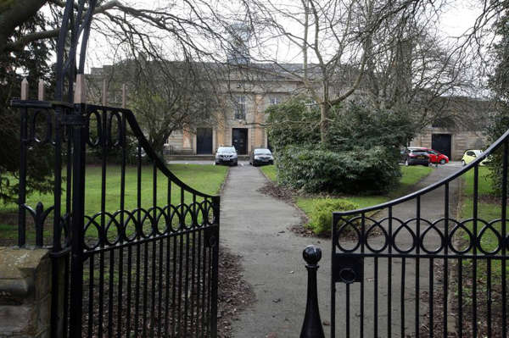
The public domain of Riverwalk | 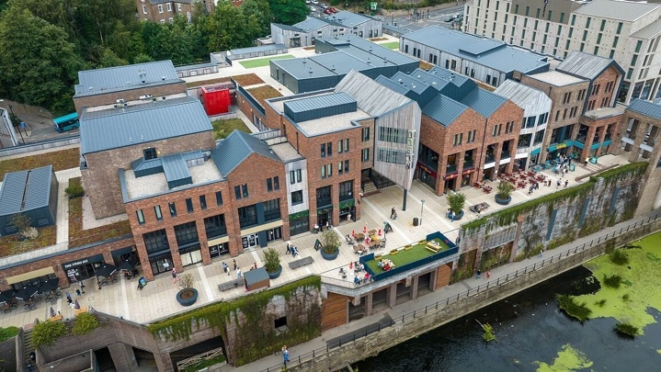
The space behind Ebony on Walkergate | 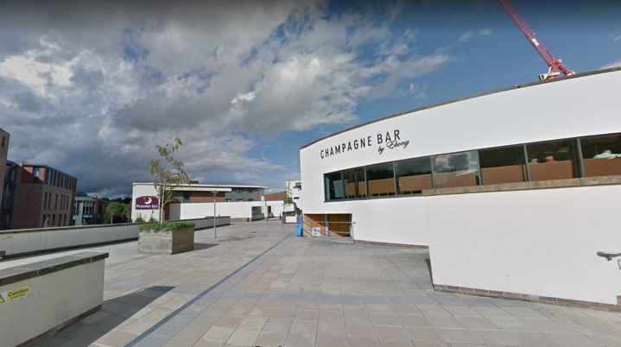
The area around Dunelm House | 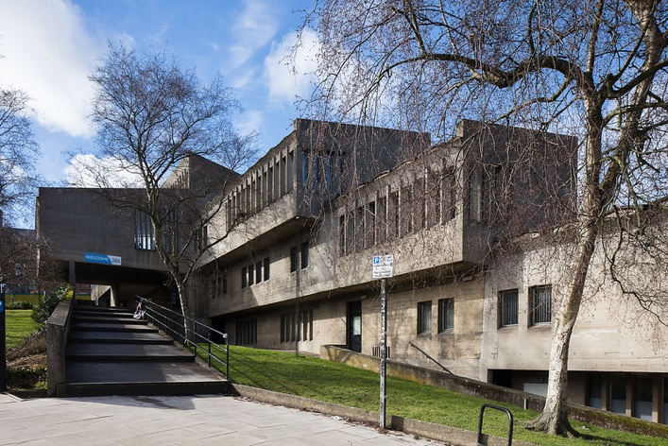

We’ve already started programming Lumiere 2023, using lots of spaces across the city. Iconic sites such as Durham Castle, the Market Place and the Cathedral have already been allocated. Your application is less likely to succeed if you suggest these well-known locations for your artwork.

ELIGIBILITY

Who can apply?
- Anyone aged over 18
- Anyone currently living in the UK

We are particularly interested in receiving applications from:
- Individuals who are currently living in or are originally from the North East and are local to Durham

Those who are under-represented in our BRILLIANT alumni, particularly:
- Those who identify as a person of colour
- Those who identify as a person who is d/Deaf, disabled or neurodivergent

As part of Artichoke’s ongoing commitment to the development of local creativity, up to three of the six BRILLIANT commissions are reserved for people or groups who are currently living in or originally from North East England.

INCLUSION AND DIVERSITY
Artichoke is committed to broadening the diversity of those working in the medium of light art and encourages applications from people who are currently under-represented in our BRILLIANT alumni, including people of colour and people who identify as d/Deaf, disabled or neurodivergent.

We ask demographic questions in the application form to help us understand our artists and audiences, but this information is not mandatory and you can choose not to complete this part of the form if you prefer.

To ensure that a diversity of voices is represented in the exhibition, the selection process will not be anonymous and the selection panel will have access to the demographic information provided if artists choose to include this in their application form.

Asking for demographic information also helps us to monitor how well we are reaching our organisational aims. In addition, we may be required to report on this data as part of funding agreements.

All information will be kept securely in line with General Data Protection Regulations, and any data submitted to a funder will be amalgamated and anonymised.

WHAT YOU GET

What happens if my idea is chosen?
BRILLIANT artists will be supported by event producers Artichoke to develop and create their own light installation. They will also receive ongoing mentoring and advice.

BRILLIANT artists receive:
- A fee of up to £1000
- Support from an Artichoke Producer and Production Manager to realise their BRILLIANT idea
- Production/materials/fabrication/installation costs up to £7000
- Artichoke will pay for the costs of event management and security associated with your installation
- Bespoke professional development, including ongoing mentoring and advice after Lumiere
- An international platform to exhibit your artwork. Lumiere is attended by hundreds of thousands of people and receives significant coverage from local, national and international media
- Introduction to appropriate networks to support future exhibitions and showings of your artwork

HOW DO I APPLY?
There is a two-stage application process:

- Stage One
Complete the short application form to apply for BRILLIANT. We ask you to tell us a little bit about yourself, provide an outline of your idea and how the public might experience it. Please adhere to the word limit.

There is space in the application form to tell us what materials your artwork might be made of, give a rough estimate of how much it might cost, where you think your artwork could be located and attach any photos or drawings.

Applications can be completed online by clicking this link: https://www.lumiere-festival.com/brilliant-2023/

To request the application form in an alternative format or to receive additional support with completing your application please call the Artichoke office on 020 7650 7611 (Mon-Fri 10am – 6pm) or email brilliant@artichoke.uk.com

The Lumiere website has the application form as a downloadable Word document if you are unable to access the online form.

Closing date for applications: 11:59pm, Sunday 19 February 2023

Do I need to calculate an exact budget?
BRILLIANT is a small-scale, national commissioning scheme. Successful applicants will each receive a fee of up to £1000. Previous budgets for fabrication and delivery of the artwork have ranged from a minimum £500 up to a maximum of £7,000.

We have included a space on the application form for you to give us a rough estimate of what your artwork might cost to make and install.

If you are selected for Stage Two, we will support you to develop a comprehensive budget as part of your proposal.

- Stage Two

Initial online meeting and detailed proposal
If your Stage One application is successful, you will be invited to an initial meeting, ideally held in person in Durham with an Artichoke Producer and Production Manager to discuss your application. You will need to be available for this meeting.

Meeting dates are during the day on either Wednesday 22nd, Thursday 23rd, Friday 24th March 2023. Ideally each meeting will be held in person in Durham to include a site visit. If this is not possible, the meeting will take place via Zoom and will last approximately two hours.

Following this initial meeting you will be asked to submit a more detailed proposal. You will be given four weeks to do this, and will receive support from Artichoke to develop your idea further. This will include support with putting together a more detailed project budget, technical advice on how the piece could be made and help with possible locations.

Interview with Selection Panel
Once your Stage Two proposal is completed, you will be invited to attend an interview with a selection panel. The meeting will be held in person in Durham on either Tuesday 25th, Wednesday 26th or Thursday 27th April 2023. Further details will be given if you are successful at this stage.

If you cannot make any of these dates, please let us know this in your application. We will support applicants with travel/accommodation and specific requirements to attend a meeting and interview if required.

THE SELECTION CRITERIA

Awards will be given based on:
- The quality of your idea
- How inspired is the idea is e.g: what is the background story and how is this represented visually?
- How the idea might fit with other programmed artworks
- Your ability to work with us to create the artwork within the budget, taking into consideration the technical requirements, installation and material costs

SUPPORT

If successful, Artichoke will help you with:
- Initial production advice, including practical and technical support
- Support with developing your idea and budgeting
- Permissions and licenses for use of the space
- Production and technical support
- Health and Safety management
- Site security and stewarding
- Press and marketing
- Travel and accommodation

KEY THINGS TO REMEMBER:

- You must be living in the UK to apply.

- You must be aged 18 years or over.

- You do not need to be an artist to apply. We welcome applications from anyone with a BRILLIANT idea.

- Applicants can only submit one application and we will consider your first application only.

- Ideas must be original. Applicants who have previously applied to BRILLIANT but have been unsuccessful can only apply with a new idea.

- We cannot accept applications from previous BRILLIANT artists.

- You cannot change your application form once it has been submitted.

- BRILLIANT artists will be decided by a panel working to agreed criteria. We will contact you after the closing date to let you know the result of your application. Unfortunately, due to the high number of applications we anticipate, we will not be able to offer feedback on unsuccessful Stage One applications.

- The first showing of this artwork must be at Lumiere 2023.

- Your work must be exclusively available to show in Durham from Thursday 16 November 2023 for the entire event period (until Monday 20 November 2023) and for an installation period of up to one week in advance.

- You should be present for the install and deinstallation of your artwork or plan to provide an appropriate person on occasions where you cannot be present.

- You must be available to attend Production meetings and site visits when required (dates will be discussed with you in advance).

- You will need to agree to a fabrication timeframe and budget with Artichoke (producers of Lumiere) in advance. You will be issued with a written contract that will refer to this.

- You must be willing to support Artichoke with the promotion of your work and the BRILLIANT scheme and be available to give interviews to the press and media if required.

- The final installation will be produced and promoted by Artichoke and its partners.

- The copyright and intellectual property of your artwork and services will belong to you. However, if your idea is selected for BRILLIANT, you will agree that Artichoke has the artwork exclusively for the purposes and period of Lumiere 2023.

- Following Lumiere 2023, you will be responsible for the disposal or future storage of your work. Artichoke will advise on how to do this in a sustainable way where possible.

- If successful, when exhibiting your work after the event, you must acknowledge it was commissioned by Artichoke for Lumiere 2023 in Durham.

